Home Page:

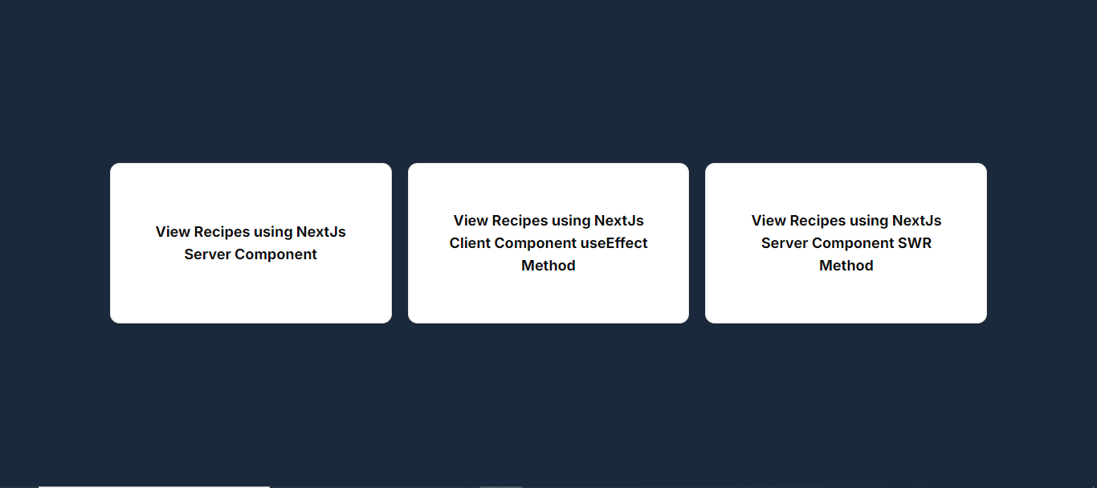

Show All Recipes Page:

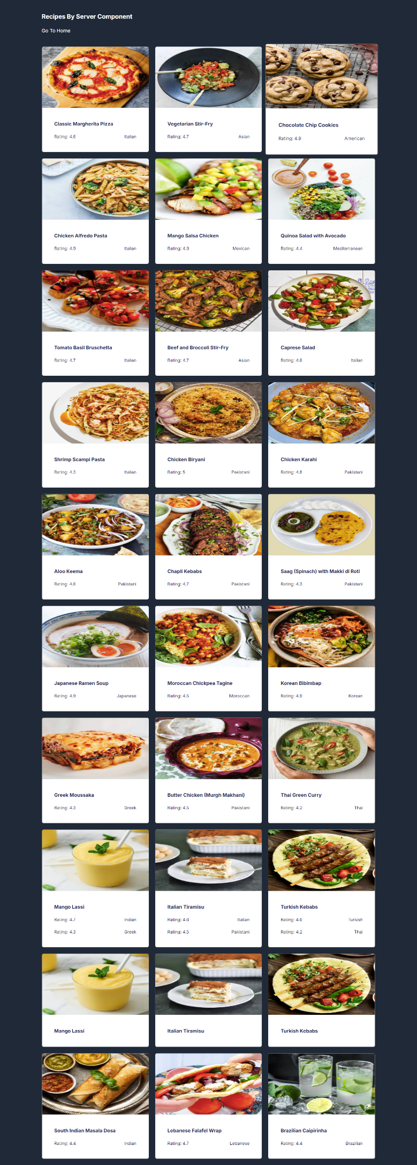

Show Detail of a Recipe Page

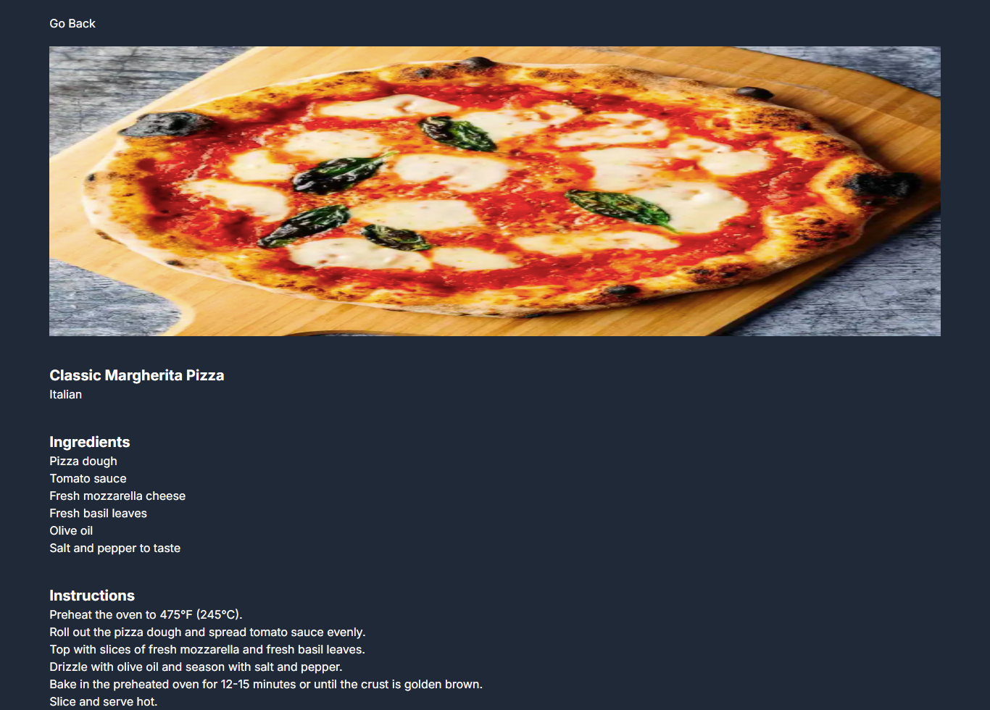

* You have to fetch page 2 and page 3 by using 3 methods
  + Server components
  + Client components (useEffect Hook)
  + Client components (SWR Hook)